Appendix 6 New Features in v4.0
The Version 4.0 adds several features, including a totally new Plus version. Now the program includes these 4 levels:
- Roll Center Calculator v4.0 (front suspension only)
- Roll Center Calculator ‘Plus’ v4.0 (front and rear suspension)
- Circle Track Analyzer v4.0 (front and rear suspension, engine, vehicle, track and lap time simulation)
- Circle Track Analyzer ‘Plus’ v4.0 (all CTA features plus advanced inputs and outputs)

New Calculations
Roll Center for Double A Arm and McPhearson Strut suspensions are now calculate using the Force Based Roll Center methodology. This method is more accurate and realistic. You will no longer see roll centers being calculated, say, 50 or 1000 inches beyond the track of the car, which never made much sense. Force Based Roll Centers are more accurate than the old "Kinematic Roll Center" method of earlier versions. There are options for you to display either or both, and go back to the old Kinematic Roll Center method in you want. This is set under 'Options' in the Front Suspension (Roll Center Calculator) screen. Fig A20.

The program's Lap Time and "On Track" Handling Calculations now include mass effects of the vehicle. This will, produce more realistic handling, spring, and shock motion, body roll, dive, squat, etc as it goes around the track. Circle Track Analyzer and Circle Track Analyzer Plus Versions only.

You can now enter details about Bump Springs and Ride Height in the Front Suspension screen, and watch their effect as you go through dive, roll, and pitch. Fig A21, Fig A29.

The program lets you specify if the shock is mounted in the middle of the spring, as with coil over springs. Or you can specify if the shock is farther inboard or outboard of the spring and by how much. This can greatly affect shock absorber performance and bump spring performance if it is mounted on the shock absorber. Fig A21.

IMPORTANT: If the Bump Springs are mounted on the shocks, the program will calculate the force the bump springs adds to the springs. For example, if the shocks are, say, 5” outside the springs, the bump springs will have more effect out there because the motion ratio is higher. Let’s say the actual bump spring force is 400 lbs at the shock. But at the spring itself, this could be the same as a bump spring on the spring adding 900 lbs. The program will report this as 900 lbs because that is the effect on the suspension and handling.

You can now include some simple shock absorber inputs which will affect the wheel loads and the handling ratings for the program's Lap Time and "On Track" Handling Calculations. Circle Track Analyzer and Circle Track Analyzer Plus Versions only. Fig A21

IMPORTANT: The vehicle dynamics simulation is assuming a perfectly smooth track and only smooth applications of throttle, brake and steering. In real racing this is hardly the case. Real world, more abrupt changes in these inputs to the vehicle will have a large effect on shock velocities and therefore shock forces.

The Circle Track Analyzer Plus version allows you to input more details about shocks and travel limits of the springs. You can also import shock data from proper versions of the Performance Trends Shock Dyno software. Circle Track Analyzer Plus Version only. Fig A21 – A24 B.

Program now has refined the method of calculating the spring Motion Ratios for Double A Arm and McPhearson Strut suspensions to better match the Suspension Analyzer.

The program will now calculate how much the Ball Joint/Spindle Angle changes as you go through suspension movement. This will help you identify if the Ball Joints can go into bind, being pushed past the limit in Ball Joint Angle change. Fig A28

Program now calculates several suspension handling outputs each time you calculate a lap time. These new outputs like Dive, Roll, Squat, etc can be reported or graphed.

Original Report Data, version 3.6 or earlier

Time | Feet
MPH | Accel Gs
% Throttle | Eng RPM
Turn # | Curvature
Downforce | Corner Gs

New Report Data, Circle Track Analyzer v 4.0

OSUS Factor | Left Camber
Right Camber | R.C. Left
R.C. Height | Roll
Dive | Squat
Left Scrub | Right Scrub
L Upper BJ Angle Change | L Lower BJ Angle Change
R Upper BJ Angle Change | R Lower BJ Angle Change

New Report Data, Circle Track Analyzer v 4.0 Plus

LF Tire Force | RF Tire Force
LR Tire Force | RR Tire Force
Total Tire Force | LF Bump at Tire
RF Bump at Tire | LR Bump at Tire
RR Bump at Tire | LF Spring Force
RF Spring Force | LR Spring Force
RR Spring Force | LF Shock Force
RF Shock Force | LR Shock Force
RR Shock Force | LF Shock Vel
RF Shock Vel | LR Shock Vel
RR Shock Vel | LF Ride Ht
RF Ride Ht | F Aero Downforce
R Aero Downforce | Change CG Ht
L Bump Force | R Bump Force

Program now has a more detailed Roll Bar Rate calculator with more inputs and better accuracy. Fig A21, A26.

The results now let you input or watch "Rear Squat" in the calculations, how much the rear suspension goes down measured from directly above the rear axle to the ground.

The Oversteer/Understeer factor has been refined to be more realistic. In earlier versions it depended too much on the front to rear weight distribution.

Ride Height is now and input and you can watch Ride Height change as the car goes through Dive, Roll and Squat. Squat (the amount the rear ride height goes down) is a new input and output. Fig A29

New Features
You can now write the results on the Reports screen to an ASCII data file for doing your own custom analysis in other programs, like Microsoft Excel. Circle Track Analyzer Plus Version only. Fig A30.

You can now shim the upper A Arms up or down in the Front Suspension (Roll Center Calculator) screen. Fig A31.

The program now will let you report more than double of the points as before when you go around the track, for more detailed analysis, reports and graphs. Circle Track Analyzer and Circle Track Analyzer Plus Versions only.

The engine screen and engine graph are now enlarged to show more detail. Also, the Engine Screen has a note explaining the Max RPM and how critical it is to get that correct. It also has a feature to help you enter data to realistically represent the power curve at its max RPM, past the HP peak. The new version has several new crate motors added as examples. Circle Track Analyzer and Circle Track Analyzer Plus Versions only. Fig A32.

The program now works much better when closing the Analyze Suspension screen. It also gives you 2 options of “Back” (simply closing the screen) or “Back (and save as baseline)”. Previous versions would ask you each time you closed this screen if you wanted to save the current results as the Baseline. Circle Track Analyzer and Circle Track Analyzer Plus Versions only. Fig A33.

Many screens and input fields are now larger to accommodate longer file names. Fig A34.

The program now lets you pick which columns of output data to display and print under the "View" option on the Report Screen. These combinations of which columns to view can be stored as “templates” for easy recall in the future. Circle Track Analyzer Plus Version only. Fig A35.

"Modifieds” are now added to the list of general body types for Aero inputs in the Vehicle Specs screen. Circle Track Analyzer and Circle Track Analyzer Plus Versions only.

Program is much more streamlined for calculating the Handling Ratings from the Main Screen, and backing out of the "Analyze Handling Performance” screen. Circle Track Analyzer and Circle Track Analyzer Plus Versions only.

There is a new Option in the Front Suspension screen of allowing very small inputs for RC size cars.

The program now works much better when calculating the handling rating. Earlier versions could require you to do the calculation 2 times to work properly.

Program now better remembers the handling rating when you enter other screens and do not make any modifications in that screen. Circle Track Analyzer and Circle Track Analyzer Plus Versions only.

Program now does not let you enter screens from the main screen until all calculations are done refreshing the handling rating on the main screen. This can avoid problems if you click through screens too fast. Circle Track Analyzer and Circle Track Analyzer Plus Versions only.

Fixed a bug where canceling from printing to a PDF printer could cause program to stop. Doubled the max size allowed for Comments to 800 characters.

Printing
Program has an added option for "Print Suspension Outputs" so you can print either the standard outputs, or the new handling outputs. Circle Track Analyzer and Circle Track Analyzer Plus Versions only.

You can now load a picture file (.jpg) on the Main Screen and in the Front Suspension (Roll Center Calculator) screen and have it appear on printouts. Fig A36, A38, A42.

You can now specify a "Company Logo" (.jpg) file and 2 lines of “Title Text” to be included in your printouts. Circle Track Analyzer Plus only. Fig A37, A38..

Program now lets you pick which columns of output data to display and print under the "View" option on the Report Screen. If you select to print all data, only the columns displayed will be printed, up to 15 columns max. Circle Track Analyzer Plus Versions only. Fig A35.

Program has an added a Preference for printer width adjustment.

The program can now better print the title of columns of output, which could be up to 3 lines long of text. Help screens are now shown in Notepad so you can print them if you want.

Graphing
You can now graph up to 4 different data types on a graph. Each of these can be assigned a factor, like “x 100”. This way small numbers like “Bump at Tire” will show up if you also include very large numbers like “RPM” or “Spring Force”. You can also save graph “templates” of various combinations of data and scaling factors under different names for use in the future. Fig A39.

You have a graph option of “(down shown negative)”. If you choose one of these option, then a number like Dive will be graphed in the opposite direction. For example, if the Dive number increases, the graph line will go up on the graph. However, the motion in the car is for the car to go down as Dive increases. If you choose the “(down shown negative)” option, increasing Dive will be a graph line that goes down and can be easier to understand. Fig A39.

The program now lets you graph results from up to 6 different tests. Fig A40.

Because these larger labels can take up more space, and with up to 24 graph lines which can be graphed (4 data types and up to 6 different tests), there may not be enough space to display all labels. Then the program will then produce "More" buttons which can appear either above or below these labels if they can not all be displayed on the screen, so you can scroll through all the labels. Circle Track Analyzer and Circle Track Analyzer Plus Versions only. Fig A40.

There is now an option to Draw Segment Lines on the Graph Screen under Format. If you choose this, vertical lines are drawn at the start of each turn and each straightaway. These lines are drawn based on the current (latest) data. So if the latest run was a 13 second lap time and the other runs you graph are about 16 seconds, these lines are based on the 13 second lap times. Circle Track Analyzer and Circle Track Analyzer Plus Versions only. Fig A41.

Background color choice is now checked in the dropdown menu in the Graph screen. Circle Track Analyzer and Circle Track Analyzer Plus Versions only.

The Graph Line Thickness has been adjusted to be slightly thinner for the "thick" settings. Circle Track Analyzer and Circle Track Analyzer Plus Versions only.

In the Graph Screen under Format, there is a new option for printing the graph labels larger than before. Fig A41.
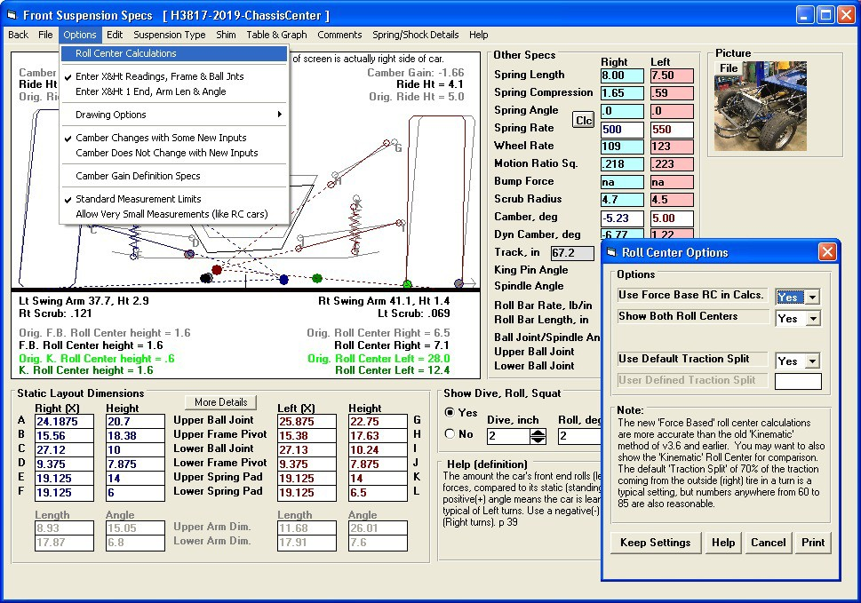
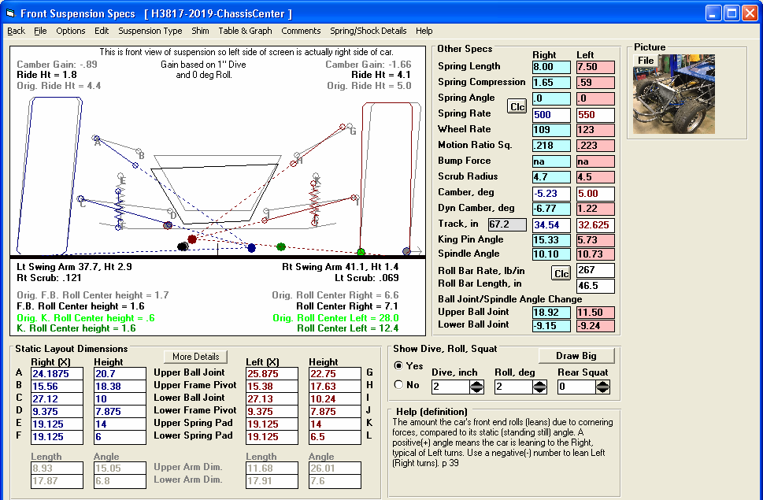
Figure A 20 Force Based Roll Center
Roll Center Options brings up screen lower right

What you pick here also determines which Roll Center is used for handling and lap time simulation.

The Force Based Roll Center depends on how much traction is produced by the right side tire vs the left side tire. The default is that 70% is produced by the right side tire. This is the outside when cornering. If you want to do something different, you can enter the % from the outside tire here.

Force Based moves very little
Old Kinematic Roll Center moves a lot, which is not as accurate or realistic as the Force Based method.

Both Roll Centers shown here when Option set to Show Both.
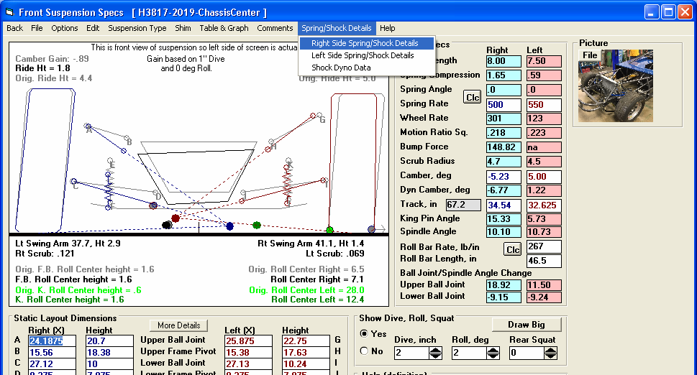
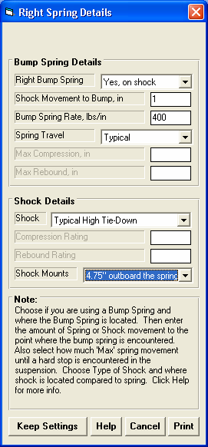
Figure A 21 Bump Spring Inputs
Click here to get Bump Spring and Shock Options

Plus version has this option described in Figs A22, A23, A24.

When the Bump Spring is encountered, you will see the Wheel Rate increase from the force produce by the Bump Spring.
When the Bump Spring is encountered, you will see the force here. Note: When the Bump Spring is not on the spring, the force shown here is not the force of the bump spring on the shock, but the effective force it puts on the suspension spring.

If you have the Plus version, you will have many more choices for Spring Travel and Shock inputs, some of which are shown here. One choice is to use a complete shock dyno curve. This is discussed in Figs A22 and A23.
Choose here if the shock is not mounted centered in the spring, like a Coil Over
Click here for more details

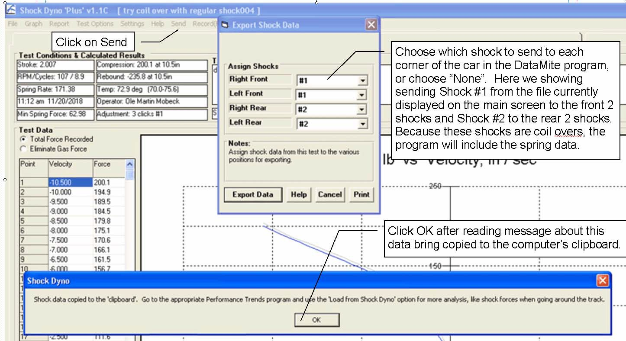

Figure A 22 Copying Shock Data from Performance Trends’ Shock Dyno Software

If you have an appropriate Shock Dyno Plus version, you can click on the ‘Send’ option and be presented with the 4 corners of the car. For each corner you can select which shock or coil over’s data to send, or choose “None” for that particular corner. You may have to open other Shock Dyno files, do the Send and select different corners of the car for sending shock data for different shocks.

As shown in the picture above, the Export Data will copy this data to the computer’s clipboard. This is the same process as doing a Windows Ctrl-C or a Copy process. Therefore, do not do a copy or paste command before you go to your Circle Track Analyzer program to import this data.
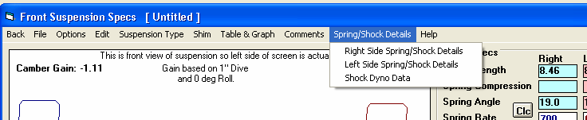
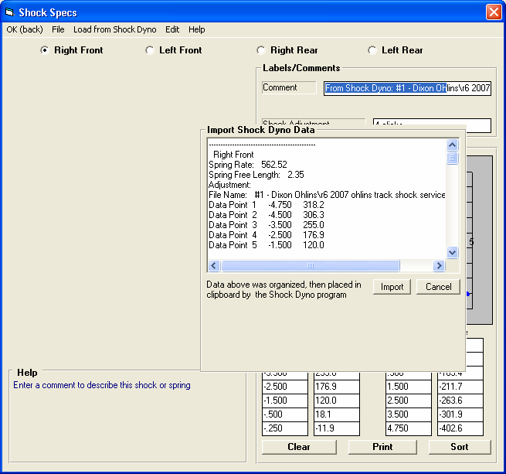
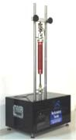
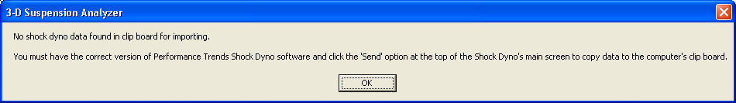
Figure A 23 Importing Shock Data from Performance Trends’ Shock Dyno Software

In Plus Version, click here to bring up the Shock Dyno table shown below, and Fig A 24. This option is also available in the Rear Suspension screen.

Click here to bring up the “Import Shock Dyno Data” field shown to the right. Click the Import button and the data from the Shock Dyno program will be written into this screen for the shocks you picked to bring over from the Shock Dyno program
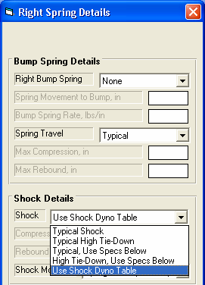
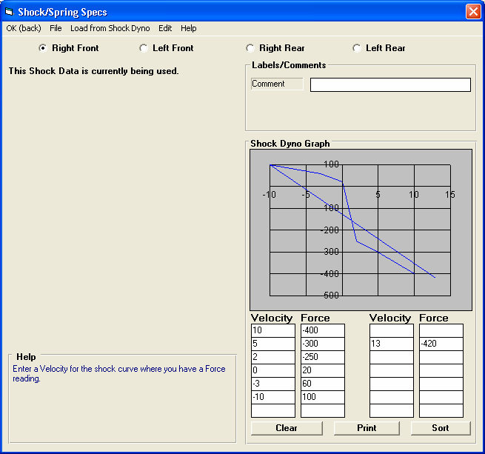
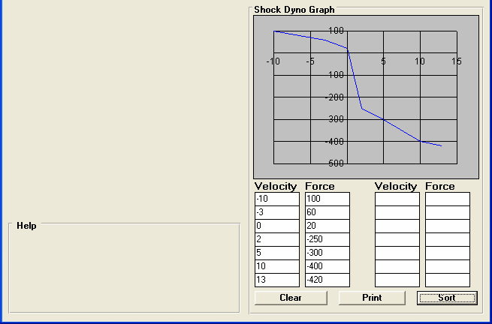
Figure A 24 A Importing Shock
Click Options to see different shock tables.

When you select Right Front, this label shows that the program will use this data to calculate shock forces.
Here we have selected to use a complete Shock Dyno Table to describe the Right Front Shock.

If you enter data into the table out of order, just click on this Sort button and the program will reorder the data. See picture below.

After clicking the Sort button, the data is organized and the graph looks correct.
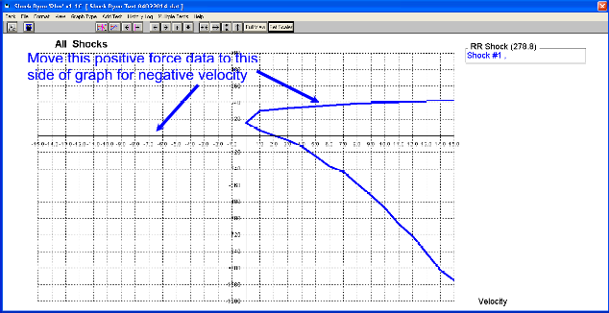
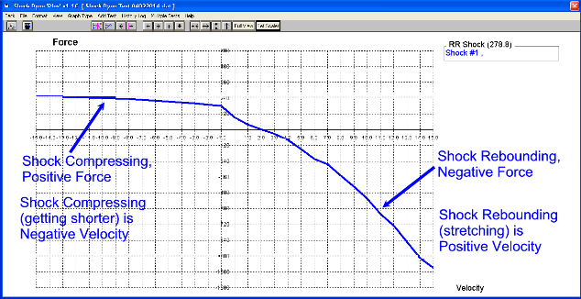
Figure A 24 B Manually Entering Shock Data

A typical Shock Dyno graph is shown below, a graph of shock force vs absolute velocity. The graph shows both the compression and rebound force (positive and negative force). But the velocity is only shown as a positive number, which is not actually correct. One reason for this is the industry does not have a common definition of positive and negative velocity. In Performance Trends programs, we have defined that a positive velocity is when the shock is expanding, or getting longer.

So, if you have a shock dyno graph like above, just take the positive forces and assign them as occurring at a negative velocity. If done correctly, the graph will angle from the upper left down to the lower right as shown below.
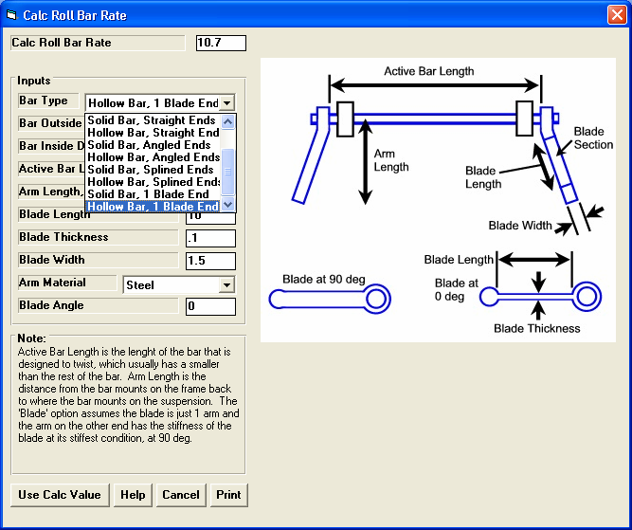
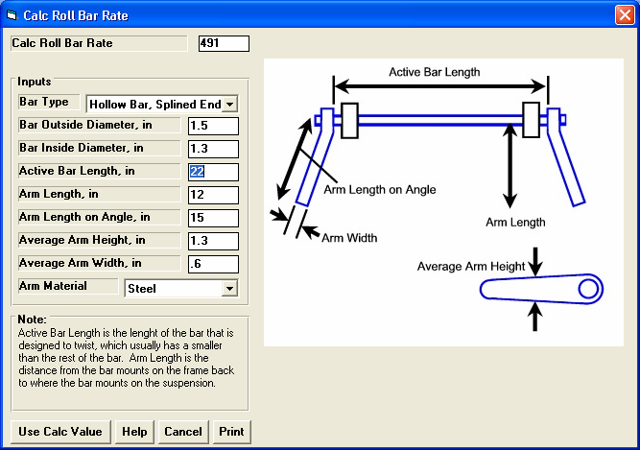
Figure A 25 More Detailed and Accurate Anti-Roll Bar Calculation Utility
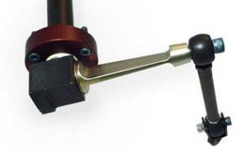
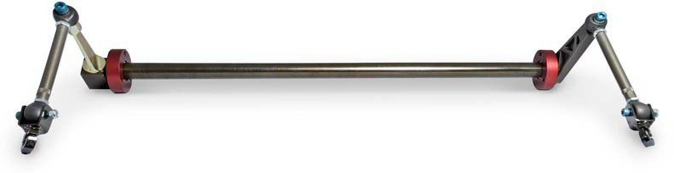
Figure A 26 Blade Anti-Roll Bar

photos courtesyelephantracing.com
In this view, the Blade Angle is approximately at 70 degrees
In this view, the Blade Angle is approximately at 10 degrees
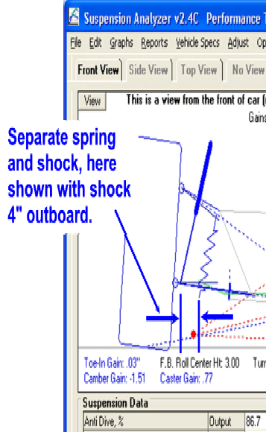
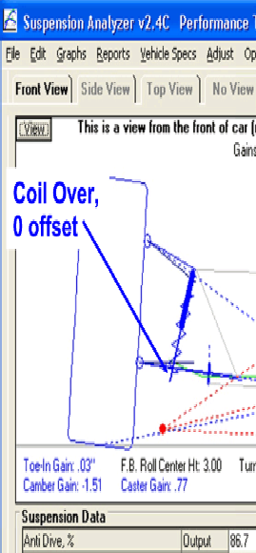
Figure A 27 Shock Offset

These pictures are from our Suspension Analyzer (which allows for more detailed inputs) to explain this input
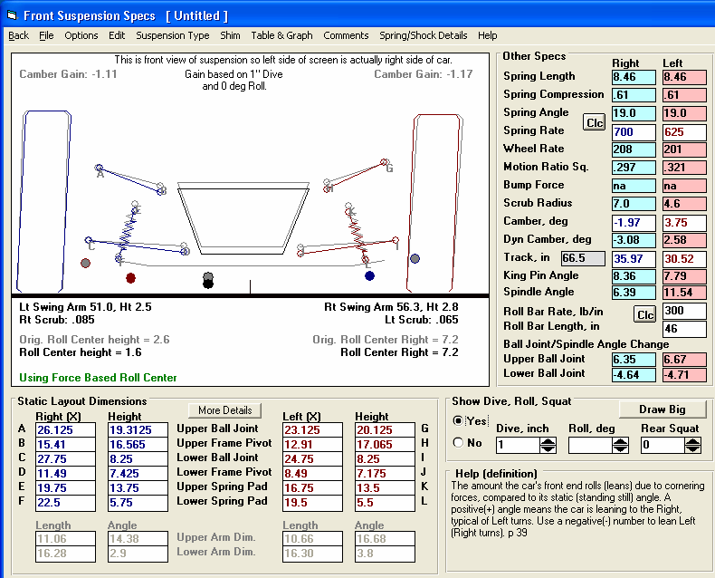
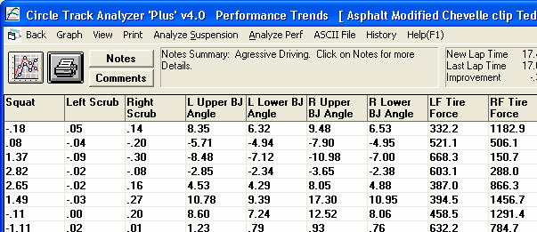
Figure A 28 Ball Joint/Spindle Angle Change

Positive Ball Joint/Spindle Angle Change means these angles are getting smaller. The Lower Ball Joint Angle actually got bigger in this case and produces a negative change.
You can watch Ball Joint/Spindle Angle Change as you put suspension through motion. If this angle change is high, you are likely putting the ball joint into bind, pushing it beyond its limits.

You can watch Ball Joint/Spindle Angle Change as you go around the track. You can also graph this data.
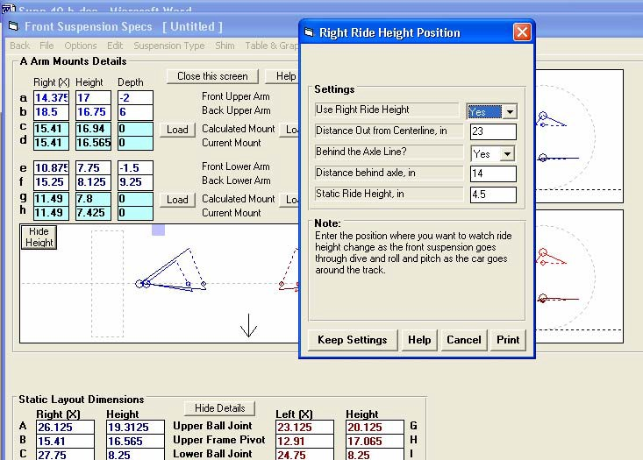
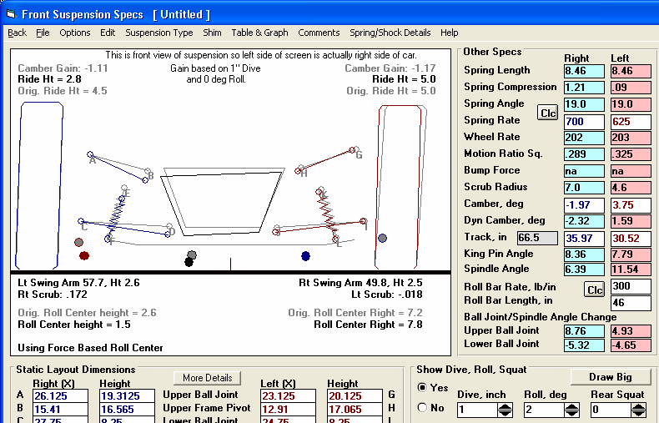
Figure A 29 Ride Height
Use this screen to specify where Ride Height is measured and what Ride Height is at static conditions.

The location of where Ride Height is measured is shown by this square.

Click here to bring up Ride Height screen.
Click on the “More Details” button (now showing “Hide Details” because “More Details” are being shown) to bring up this screen.

If you have specified Ride Height details, you will see it here, both at static and dynamic conditions. In Plus version, Ride Height will also show up in the Reports and can be graphed.
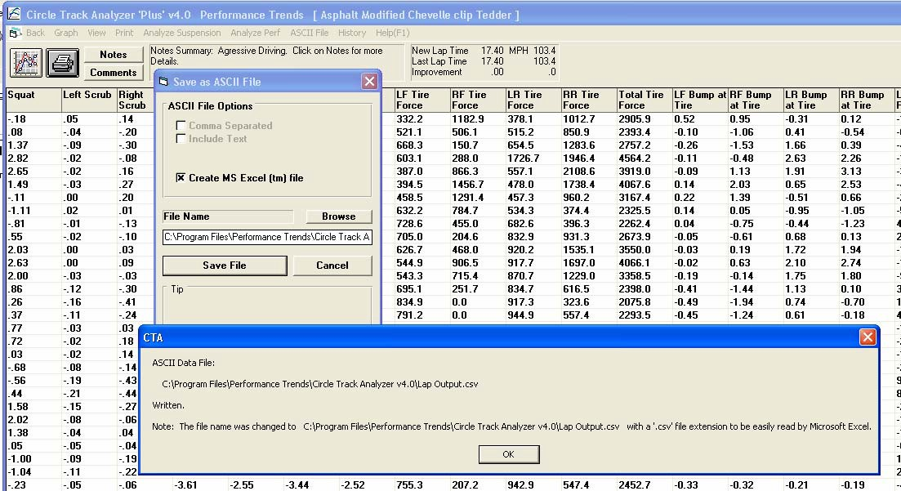
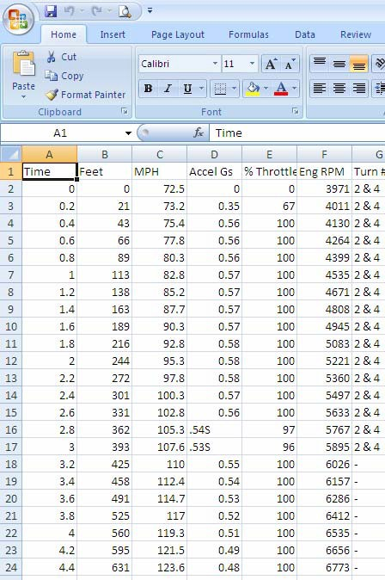
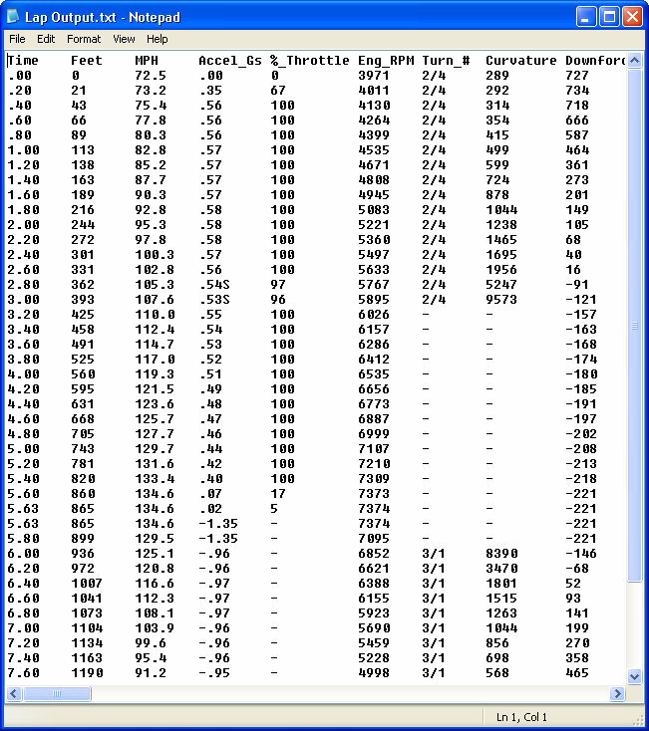
Figure A 30 Writing ASCII Data Files
Plus version has “ASCII File” option here.

If you check “Create MS Excel File”, the program will write a file with a .csv extension. Then when you open the file, Microsoft Excel will open it by default.
Here’s an example of a file written to a .txt file with “Comma Separated” unchecked and “Include Text” checked. This file opens by default in Notepad.
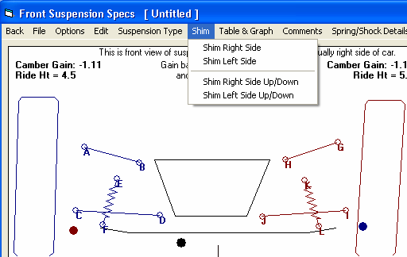
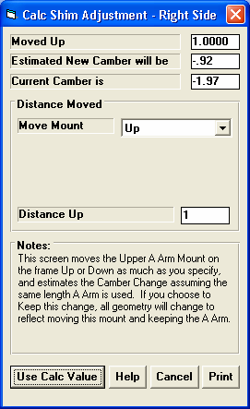
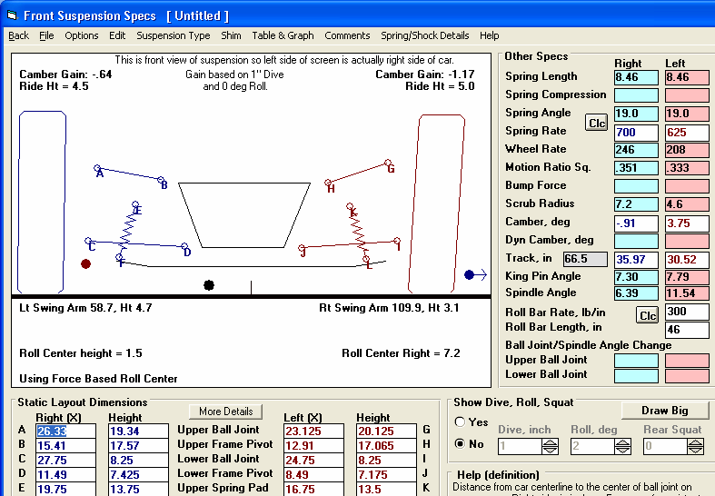
Figure A 31 New Shim Up/Down Feature
New Camber and movement of upper A Arm mount.
New Shim Up/Down features

New screen where you specify how much to move the upper A Arm mount on the frame.
Click here to use new condition, shown below.

Tire with new Camber.
New mount position.

New Camber
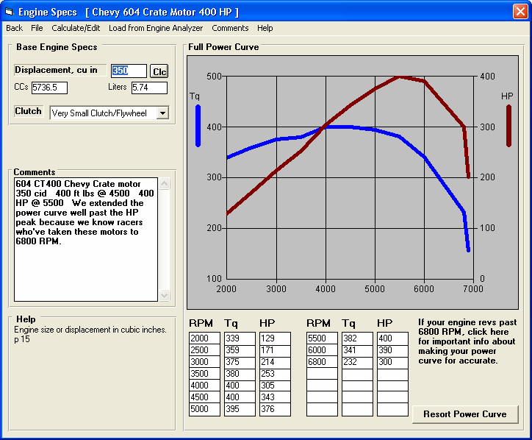
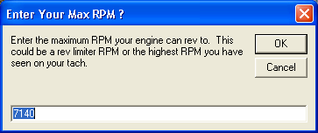
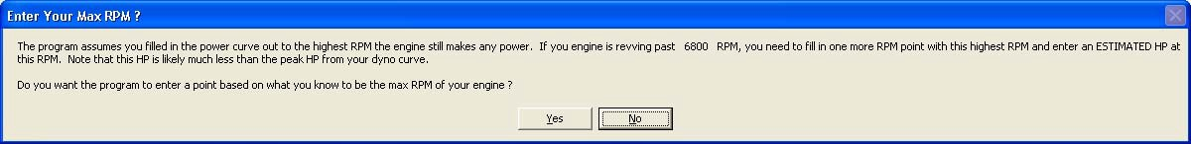
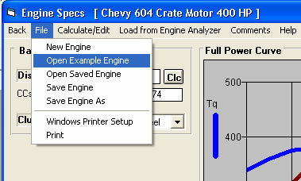
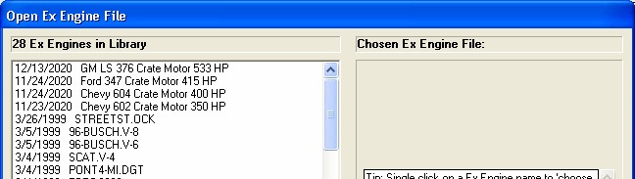
Figure A 32 New Engine Specs Screen Features

Larger graph for more detail
Here you can enter the highest RPM you have seen on your engine on the track, where the engine is still making some power.

Click here to better estimate the highest RPM on the power curve.

Click here for Example engines.

New Crate Motors.

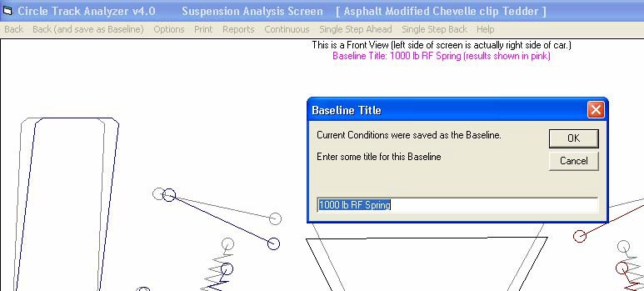
Figure A 33 New “Back” Options in Analyze Suspension
Click Back to simply close this screen, no questions asked. Previous versions would always ask if you wanted to save these conditions as a Baseline. Previous versions would only allow you to click the Red X at the upper right to close this screen.
That still works in v4.0.
Click here and you are asked for a Baseline name for saving these current data for comparisons, as shown here to the right.
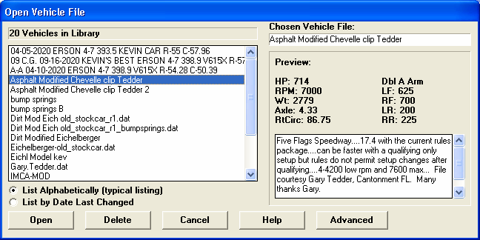
Figure A 34 New Larger Fields to Accommodate Longer File Names
Larger fields to allow for longer file names.
Figure A 35 New “View” Option, Plus Version Only
Click here to “View” only certain columns of data.

Template name (if using template) shown here.

Click Open to open previous set of selected data as a saved Template.
Click on Data types to display them in the reports. Hold down the Shift and Ctrl keys while clicking to do select multiple data types.

Click “Save” to save the current data selections as a Template for use in the future. Then enter a name for the Template.

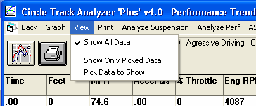
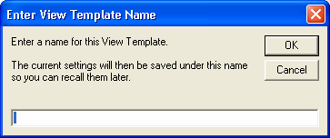
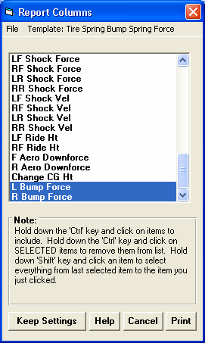
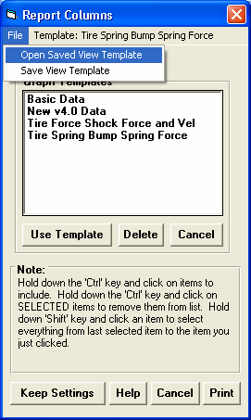
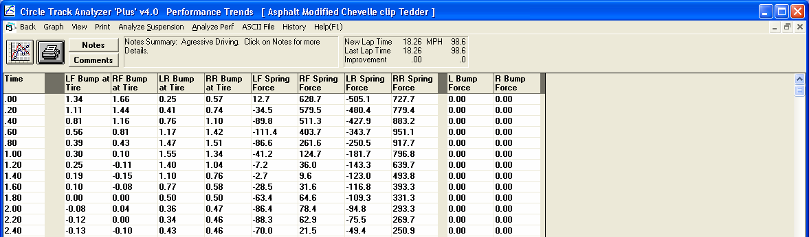

Report showing only selected Data Types (columns). If you make a printout, only these selected Data Types will be printed. This way you can get the data you are interested in to fit on a sheet of paper.

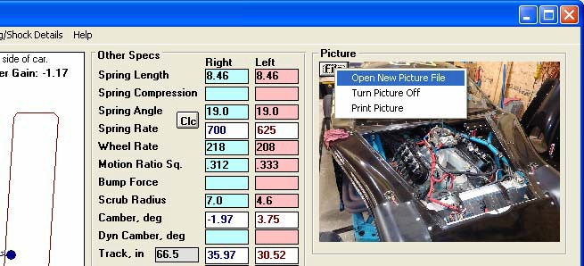
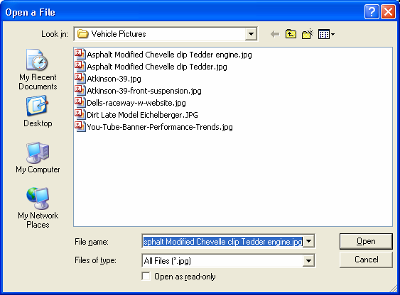
Click File button for these Options.
Figure A 36 Include Pictures with your Vehicle Files

If you choose Open, the program will typically default to the Vehicle Pictures folder, but you can browse to any folder on your computer. Note that if you move or change the location of the picture file you pick, it will not be found in the program and can not be used. For that reason it is best to keep a copy of a picture file in the Vehicle Pictures folder.
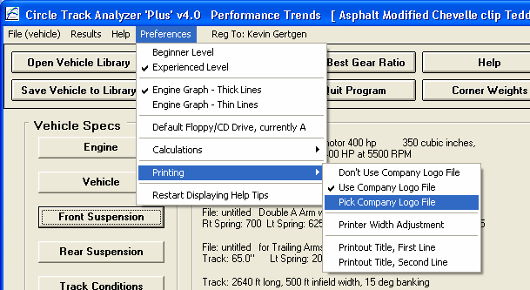
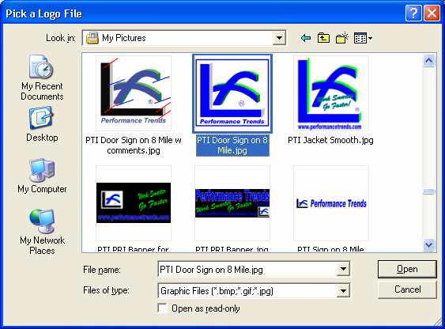
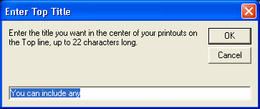
Figure A 37 Include Company Logo and Titles on your Printouts, Plus Version Only

Plus Version includes these Printing Options

Browse to locate a
.jpg file to use as your Company Logo file.

Enter 2 lines of text to appear at the top of your printouts. You do this through 2 separate screens.
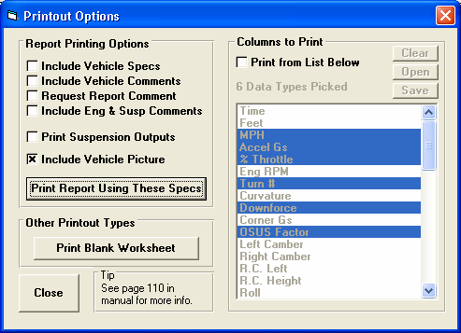
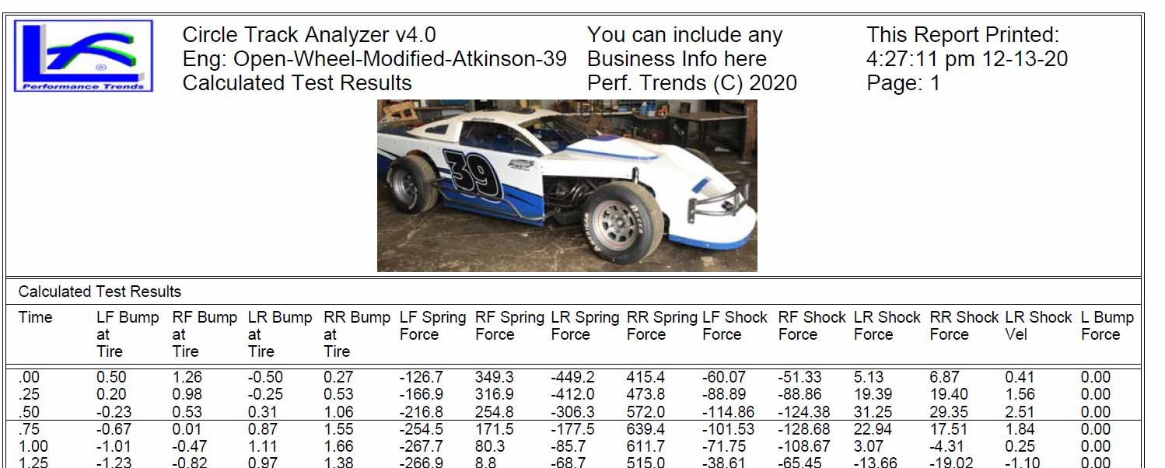
Figure A 38 Include Company Logo and Titles on your Printouts, Plus Version Only, cont

If you make a Report Printout (columns of numbers), you can select to include the Vehicle Picture here. This is the picture on the Main Screen, not the Front Suspension screen.

Company Logo graphic will appear here on printouts.
Two lines of text Titles will appear here.

Vehicle Picture will appear here, unless you print in landscape. Then it will appear smaller next to company logo graphic.
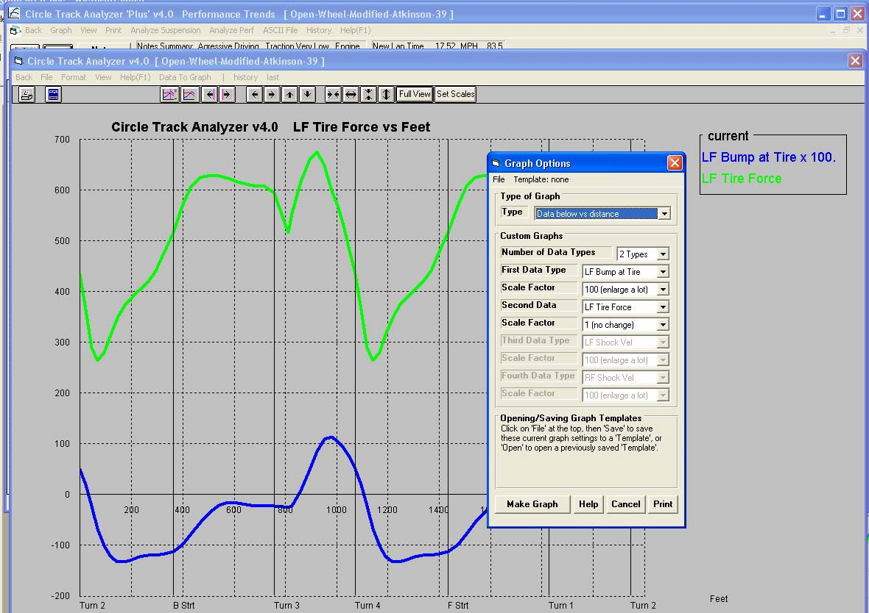
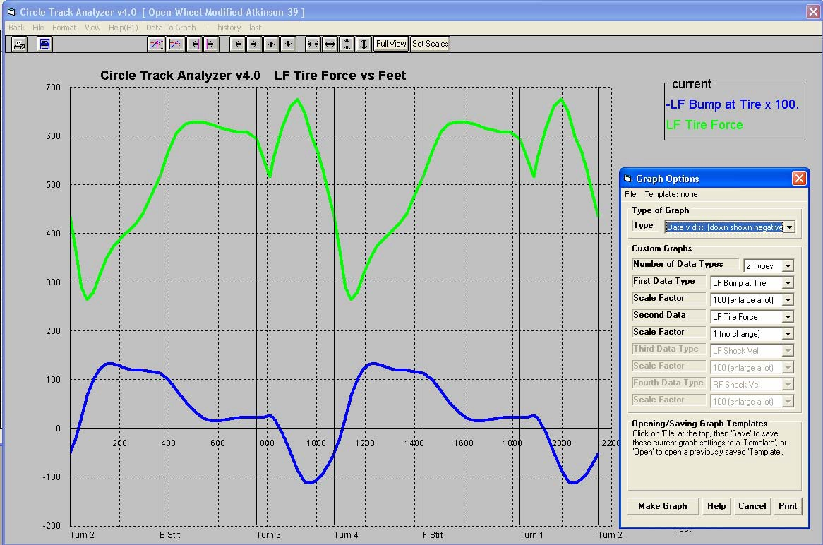
Click Graph to bring up the screen shown below.
Click Data to Graph to bring up screen shown below.
Figure A 39 New Graph Features

Scale Factor shown here.
The Scale Factor lets data of very different values be graphed so both can be seen in detail. For example, Bump could range from
-5 to 5 inches, but Force could range from 0 to 1000 lbs. If you scale up the Bump by a factor of 100, both will show on the graph.
Pick from 1 to 4 Types of Data to Graph.
Force in pounds (lbs)
Bump in inches

Bump is shown negative here for option “down shown negative”.

Here you can select to graph data vs time or distance. If you choose time and compare a fast lap and a slow lap, the car will be doing different things on the track at the same time because it is at a different place on the track. For that reason, Graphing “vs dist.” may be easier for comparisons.
Another option is “down shown negative”. On the graph above, Bump increases coming into turn 3. However, on the car, increasing Bump means the left front end is going down. Choosing the “down shown negative” option for this graph shows Bump increasing by going down, which is what the car is doing, and can be easier to understand.

Bump increasing is shown as a negative (going down), which is what the car is doing.
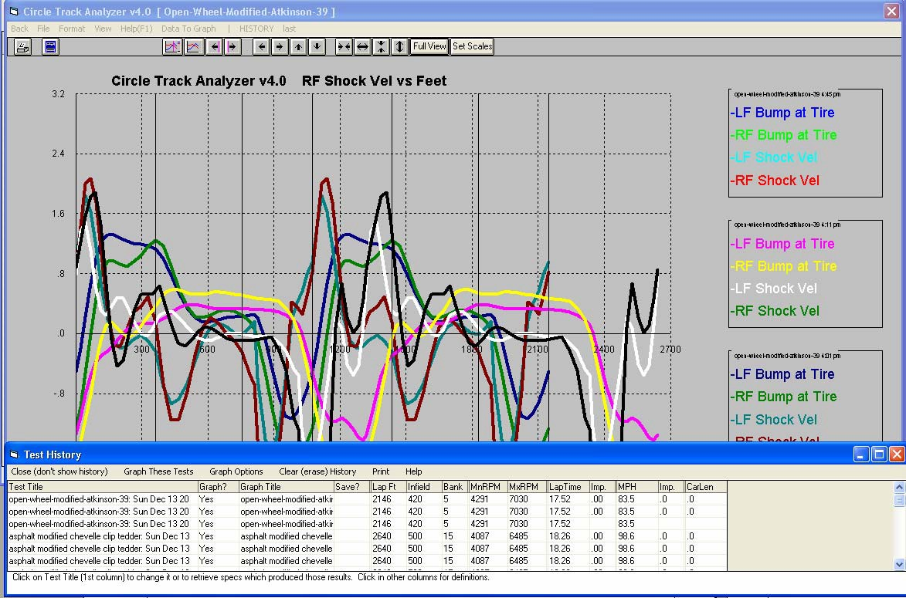
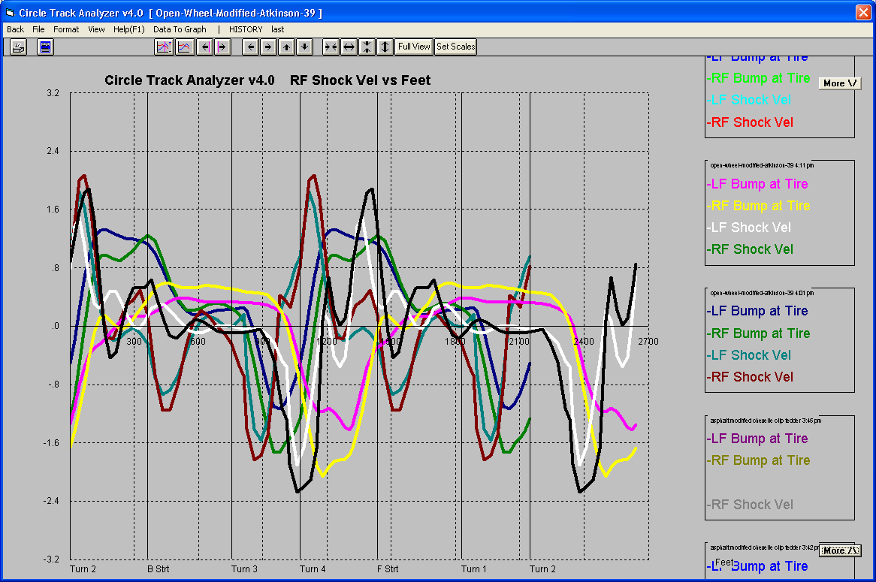
Figure A 40 New Graph Features, cont
Click History to bring up History Log shown below.

Graphing up to 4 Data Types for up to 6 Tests can produce lots of graph lines and labels on the right side of the graph.

Choose up to 6 tests to graph by clicking here to put a Yes in the Graph? column.

These More buttons let you scroll the labels on the right up and down so they all can be read.
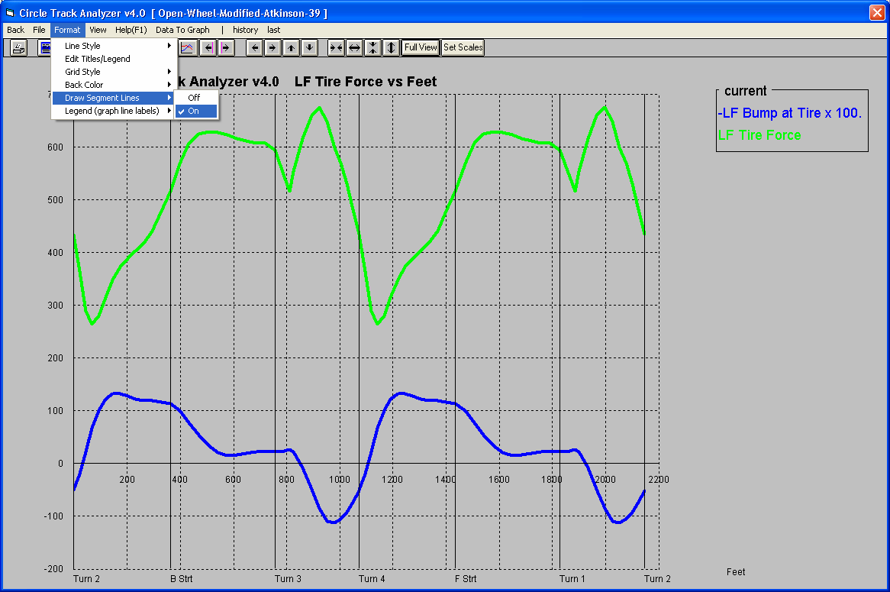
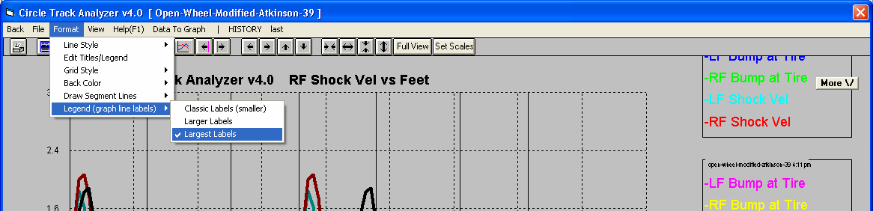
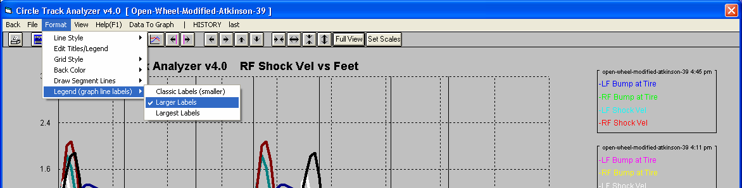
Figure A 41 New Graph Features, cont

Choose Segment Lines

Start of Turn 4
Start of Front Straight

Segment labels shown here.

Largest Labels

Larger Labels
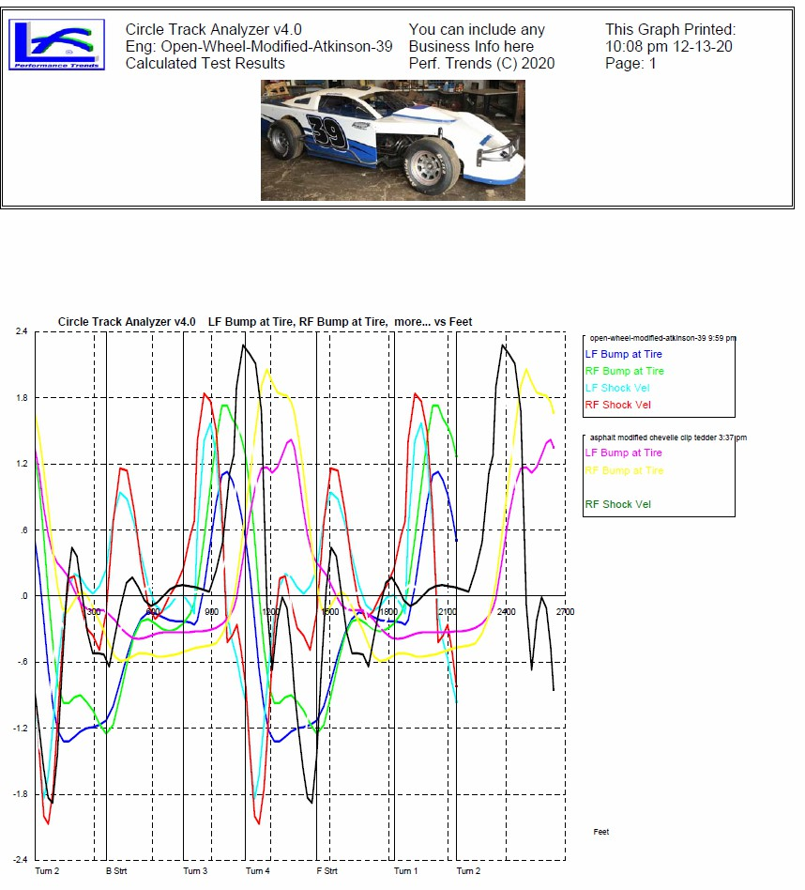
Figure A 42 New Graph Features, cont
Plus version allows for logo and title lines.

Vehicle picture from Main Screen gets printed here.

